KIST COLLEGE OF MANAGEMENT
(Affiliated to Tribhuvan university)



Project Report
On
"Management Information System"

Under Supervision of
Mr. Surya Basnet

Submitted By
Anjan Pudasaini(7210/16)

Submitted To
TRIBHUVAN UNIVERSITY
Institute of Science and Technology
Kirtipur, Kathmandu, Nepal
March, 2021

KIST COLLEGE OF MANAGEMENT
TRIBHUVAN UNIVERSITY
Institute of Science and Technology

"Management Information System"
A Project Report
Submitted To
TRIBHUVAN UNIVERSITY
Institute of Science and Technology
Kirtipur, Kathmandu, Nepal
In partial fulfillment of the requirements for the Bachelor’s Degree in Information management

Submitted By
Anjan Pudasaini(7210/16)
November , 2019
What Is Digital Firm?

A digital firm is one in which nearly all of the organization's significant business relationships with customers, suppliers, and employees are digitally enabled and mediate. Core business processes are accomplished through digital networks spanning the entire organization or linking multiple organizations. Business processes refer to the set of logically related tasks and behaviors that organizations develop over time to produce specific business results and the unique manner in which these activities are organized and coordinated. Digital firms involve both time shifting and space shifting. Time shifting refers to business being conducted continuously, 24x7, rather than in narrow "work day" time bands of 9 a.m. To 5 p.m. Space shifting means that work takes place in a global workshop, as well as within national boundaries.

Managing the Digital Firm

Toward the Digital Firm: the New Role of Information Systems in Organizations

Manager cannot ignore information systems because they play such a critical role in contemporary organizations. Responsibility for systems cannot be delegated to technical decision makers.

The Widening Scope of Information Systems

The interdependence between organizations and information systems, in contemporary systems there is a growing interdependence between organizational business strategy, rule, and procedures and the organization‟s information systems.
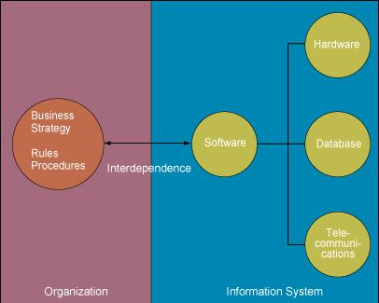

Figure 1.4 The interdependence between organizations and information systems.

New Options for Organizational Design: the digital firm and the networked enterprise

Flattening Organization

In digital firms, hierarchy and organizational levels do not disappear. But digital firms develop “optimal hierarchies” that balance the decision-making load across an organization, resulting in flatter organizations.
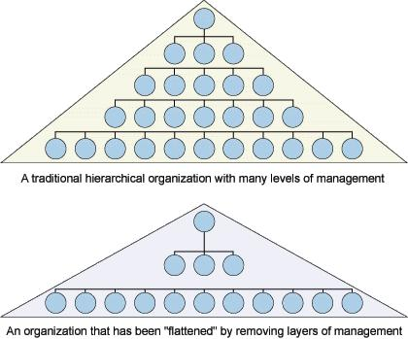

Figure 1.5 Flattening organizations. Information systems can reduce the number of levels in an organization by providing managers with information to supervise larger numbers of workers and by giving lower-level employees more decision-making Authority.
Separating Work from Location

Communications technology has eliminated distance as a factor for many types of work in many situations. Collaborative teamwork across thousands of miles has become a reality as designers work on a new product together even if they are located on different continents.

Reorganizing Workflows

Redesigned workflows can have a profound impact on organizational efficiency and can even lead to new organizational structures, products, and services.

Increasing Flexibility of Organizations

Large organizations can use information technology to achieve some of the agility and responsiveness of small organizations. Mass customization is use of software and computer networks to finely control production so that products can be easily customized with no added cost for small production runs.

The Changing Management process

Information technology is recasting the management process, providing powerful new capabilities to help managers plan, organize, lead, and control.

Redefining Organizational Boundaries

A key feature of the emerging digital firm is the ability to conduct business across firm boundaries almost as efficiently as it can conduct business within the firm. An interorganizational system is information system that automates the flow of information across organizational boundaries and links a company to its customers, distributors, or suppliers.

The Digital Firm: electronic commerce and electronic business

Electronic market is a marketplace that created by computer and communication technologies that link many buyers and sellers. Companies are also taking advantage of the connectivity and ease of use of Internet technology to create internal corporate networks called intranets that are base on Internet technology. Private intranet extended to authorized users outside the organization are called extranets and firm use such networks to coordinate their activities with other firm for electronic commerce and electronic business.

The Competitive Business Environment and the Emerging Digital Firm 4 Major Systems Defining the Digital Firm


chain management systems

Supply Chain Management

Supply Chain Management is the systematic, strategic coordination of the traditional business functions and the tactics across these business functions within a particular company and across businesses within the supply chain, for the purposes of improving the long-term performance of the individual companies and the supply chain as a whole.

- Close linkage and coordination of activities involved in buying, making, and moving a product.

- Integrates supplier, manufacturer, distributor, and customer logistics time

- Reduces time, redundant effort, and inventory costs

- Network of organizations and business processes

- Helps in procurement of materials, transformation of raw materials into intermediate and finished products

- Helps in distribution of the finished products to customers

- Includes reverse logistics - returned items flow in the reverse direction from the buyer back to the seller

"Supply chain strategies require a total systems view of the linkages in the chain that work together efficiently to create customer satisfaction at the end point of delivery to the consumer. As a consequence costs must be lowered throughout the chain by driving out unnecessary costs and focusing attention on adding value. Throughout efficiency must be increased, bottlenecks removed and performance measurement must focus on total systems efficiency and equitable reward distribution to those in the supply chain adding value. The supply chain system must be responsive to customer requirements.
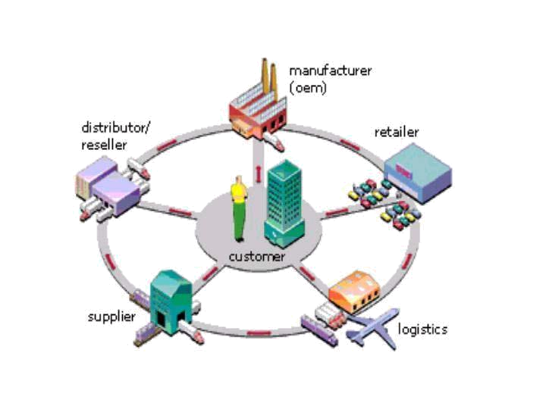

Global Supply Chain Forum

Supply chain management is the integration of key business processes across the supply chain for the purpose of creating value for customers and stakeholders.

According to the Council of Supply Chain Management Professionals, supply chain management encompasses the planning and management of all activities involved in sourcing, procurement, conversion, and logistics management. It also includes the crucial components of coordination and collaboration

with channel partners, which can be suppliers, intermediaries, third-party service providers, and customers. In essence, supply chain management integrates supply and demand management within and across companies. More recently, the loosely coupled, self-organizing network of businesses that cooperate to provide product and service offerings has been called the Extended Enterprise.

A supply chain, as opposed to supply chain management, is a set of organizations directly linked by one or more of the upstream and downstream flows of products, services, finances, and information from a source to a customer. Managing a supply chain is 'supply chain management'.

Supply chain management software includes tools or modules used to execute supply chain transactions, manage supplier relationships and control associated business processes.

Supply chain event management (abbreviated as SCEM) is a consideration of all possible events and factors that can disrupt a supply chain. With SCEM possible scenarios can be created and solutions devised.

Organizations increasingly find that they must rely on effective supply chains, or networks, to compete in the global market and networked economy. In Peter Ducker‟s (1998) new management paradigms, this concept of business relationships extends beyond traditional enterprise boundaries and seeks to organize entire business processes throughout a value chain of multiple companies

Supply chain management flows can be divided into three main flows:

- The product flow

- The information flow

- The finances flow

There are two main types of SCM software: planning applications and execution applications. Planning applications use advanced algorithms to determine the best way to fill an order. Execution applications track the physical status of goods, the management of materials, and financial information involving all parties.

Some SCM applications are based on open data models that support the sharing of data both inside and outside the enterprise (this is called the extended enterprise, and includes key suppliers, manufacturers, and end customers of a specific company). This shared data may reside in diverse database systems, or data warehouses, at several different sites and companies.

By sharing this data "upstream" (with a company's suppliers) and "downstream" (with a company's clients), SCM applications have the potential to improve the time-to-market of products, reduce costs, and allow all parties in the supply chain to better manage current resources and plan for future needs.
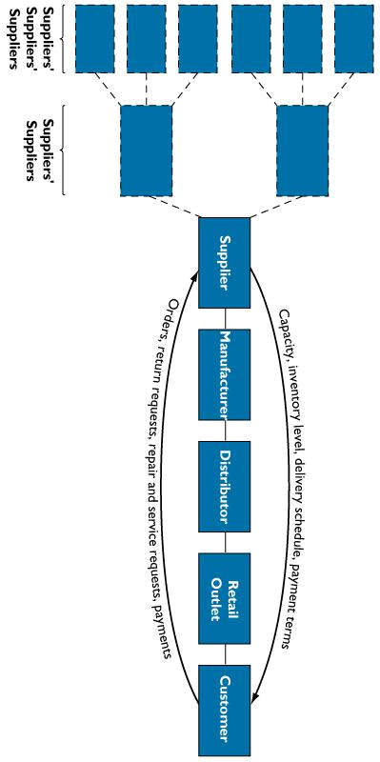
Customer Relationship Management

CRM - principles, strategy, solutions, applications, systems, software, and ideas for effective customer relationship management

Customer Relationship Management, or CRM, is an essential part of modern business management. This CRM article is provided by Ellen Gifford, who specializes in helping organizations develop excellence in CRM, and this contribution is gratefully acknowledged.

What is Customer Relationship Management, or CRM? Customer Relationship Management concerns the relationship between the organization and its customers. Customers are the lifeblood of any organization be it a global corporation with thousands of employees and a multi-billion turnover, or a sole trader with a handful of regular customers. Customer Relationship Management is the same in principle for these two examples - it is the scope of CRM which can vary drastically.
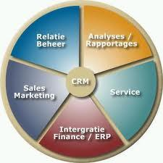

CRM focuses on the relationship

Successful organizations use three steps to build customer relationships:

- Determine mutually satisfying goals between organization and customers

- Establish and maintain customer rapport

- Produce positive feelings in the organization and the customers
CRM Conditions

The organization and the customers both have sets of conditions to consider when building the relationship, such as wants and needs of both parties;

- Organizations need to make a profit to survive and grow

- Customers want good service, a quality product and an acceptable price Good CRM can influence both sets of conditions.

Why do organizations undertake CRM?

CRM is a new concept to many organizations. If it's new to you, here's why most forward-thinking organizations devote lot of energy and resources to the set up and management of a CRM capability.

How CRM impacts on the organization

CRM can have a major impact on an organization through:

- Shifting the focus from product to customer

- Streamlining the offer to what the customer requires, not want the organization can make

- Highlighting competencies required for an effective CRM process

Why does the organization need CRM?

The ultimate purpose of CRM, like any organizational initiative, is to increase profit. In the case of CRM this is achieved mainly by providing a better service to your customers than your competitors. CRM not only improves the service to customers though; a good CRM capability will also reduce costs, wastage, and complaints (although you may see some increase initially, simply because you hear about things that without CRM would have stayed hidden). Effective CRM also reduces staff stress, because attrition - a major cause of stress - reduces as services and relationships improve. CRM enables instant market research as well: opening the lines of communications with your customers gives you direct constant market reaction to your products, services and performance, far better than any market survey. Good CRM also helps you grow your business: customers stay with you longer; customer churn rates reduce; referrals to new customers increase from increasing numbers of satisfied customers; demand reduces on fire-fighting and trouble-shooting staff, and overall the organization's service flows and teams work more efficiently and more happily.

Features of good CRM

The old viewpoint in industry was: 'Here's what we can make - who wants to buy our product?'

The new viewpoint in industry is:

- 'what exactly do our customers want and need?' and

- 'What do we need to do to be able to produce and deliver it to our customers?'

This is a significant change of paradigm and a quantum leap in terms of how we look at our business activity.
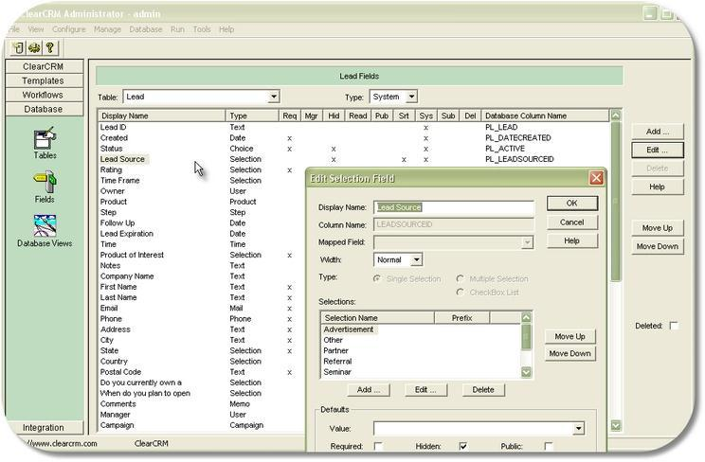

What do customers want?

Most obviously, and this is the extent of many suppliers' perceptions, customers want cost-effective products or services that deliver required benefits to them. (Benefits are what the products or services do for the customers.) Note that any single product or service can deliver different benefits to different customers. It's important to look at things from the customer's perspective even at this level.

More significantly however, customers want to have their needs satisfied. Customers' needs are distinctly different to and far broader than a product or service, and the features and benefits encompassed. Customers' needs generally extend to issues far beyond the suppliers' proposition, and will often include the buying-selling process (prior to providing anything), the way that communications are handled, and the nature of the customer-supplier relationship.

Modern CRM theory refers to the idea of 'integrating the customer'. This new way of looking at the business involves integrating the customer (more precisely the customer's relevant people and processes) into all aspects of the supplier's business, and vice versa. This implies a relationship that is deeper and wider than the traditional 'arms-length' supplier-customer relationship.

The traditional approach to customer relationships was based on a simple transaction or trade, and little more. Perhaps there would be only a single point of contact between one person on each side. All communication and dealings would be between these two people, even if the customers' organization contained many staff, departments, and functional requirements (distribution, sales, quality, finance, etc).

The modern approach to customer relationship management is based on satisfying all of the needs - people, systems, processes, etc - across the customer's organization, such as might be affected and benefited by the particular supply.

Generating a customer focused CRM solution

So what do we need to make this quantum leap of customer integration?

A new way of thinking:

- Change in paradigm

- Change in the messages sent and received

- Change in the overall culture

And a new way of doing things:

- Processes that are capable and effective

- Structures and systems that support a business centered on its customers
- Connectivity (end-to-end processes) both internally and externally (e.g., with suppliers)

Customers' expectations

If an organization cannot at least meet its customers' expectations it will struggle.

Ideally a business organization should exceed its customers' expectations, thereby maximizing the satisfaction of its customers, and also the credibility of its goods and services in the eyes of its customers.

Customers normally become delighted when a supplier under-promises and over-delivers. To over-promise and under-deliver is a recipe for customers to become very dissatisfied.

Rule No 1 - You cannot assume that you know what a customer's expectations are ... You must ask.

Rule No 2 - Customer expectations will constantly change so they must be determined on an on-going basis.

The expectations of different customers for the same product or service will vary according to:

- Social and demographic factors

- Economic situation

- Educational standards

- Competitor products

- Experience

Therefore, given all these variable factors, it is no surprise that one size certainly does not fit all.

Ask your customers what is important to them. Find out why your customers do business with you. There are a wide variety of relationship drivers. For example:

- Quality

- Price

- Product

- Location

- Customer Service

When you ask you might discover some factors that you'd perhaps never even considered, for example:

- Health and safety support

- Systems compatibility

- Contract structure

- Distribution flexibility

- Technical support

- Troubleshooting and problem-solving, to name just a few What service features will keep your customers loyal to you? Find out.
CRM as a process

CRM can be regarded as a process, which has:

- Identifiable inputs

- Identifiable components

- Identifiable characteristics, which define CRM for your organization and customer base capacity for improvement and evolution over time

Managing Customers

Why manage customers? Customers are the usual source of income for an organization. (If not then they will certainly leverage your income, as in the case of readers of a free publication which is funded by advertising. As such there are two types of customers: the readers and the advertisers).

Customers are also an exceptional source of information - information which is vital to enable a business to succeed; i.e., giving customers what they want.

Managing customers entails:

- Knowing what customers want and need - which enables you to focus your production and service efforts

- Knowing which products or customers have most growth potential - which enables you to focus on developing highest potential

- Knowing which products or customers are most or least profitable - which enables you to focus on maximizing profit

- Knowing which customers will be advocates and supporters - which enables you to provide references, case studies, and to safely test new products and services

Achieving Good CRM

Achieving effective Customer Relationship Management requires many organizations to adopt a new perspective. Consider the following:

- Traditional customer service is something you 'do to' the customer

- Modern Customer Relationship Management is 'done with' the customer

The second statement is emphasizes the big differences between conventional traditional customer service, and the modern progressive CRM approach.

- Your relationships with customers should be ongoing, cooperative, and built for the long term.

- Organizations that have many transitory relationships with customers consequently have to spend a lot of money on finding new customers.

- The cost of keeping existing customers is a tiny fraction of the cost of acquiring new customers.

Focus on Building Relationships

The essential CRM focus of any organization should be on developing core competencies, and an overall strategy of building customer relationships. In this way, all efforts in the organization can be aligned to:

- Customers and the culture of exceeding of customer expectation

- Understanding and managing the people impact on the culture of the organization

- Customers being recognized and treated as partners

- The value of relationship-building being valued

- Service being seen as a value-adding activity

- Reward and recognition being based on customer focus i.e., 'going the extra mile'

- Evidence of corporate support for service activity

Characteristics of Excellent CRM

The following characteristics are associated with delivery of excellent CRM:

- Reliability

- Responsiveness

- Accessibility

- Safety

- Courtesy

- Consideration

- Communication

- Recognizing the customer

- Competence

CRM and communications

Communication is central to any successful relationship. In terms of Customer Relationship Management, communication needs to be consistent and high quality; as determined by:

- On time

- Focused

- Relevant

- Reliable

- Coherent

Importantly also, for effective communications it's the message and meaning that is received that counts, irrespective of what the communicator thinks they've said, or written. Communications must be judged most vitally by the reaction of the receiver. If the reaction is not good then the communication is poor.

The information contained in a CRM system allows communication to be directed at the correct audience, in the correct way. The communication system must also encourage and facilitate honest and actionable
feedback.

Feedbacks from customers - especially complaints - are essential for good organizational performance and ongoing development. Most organizations avoid, discourage and hide from complaints. Don't. Complaints are free guidance for improving your quality, and free opportunities to increase customer loyalty.

People and CRM

As with any other business process your people have a huge impact on the success of the CRM process.

Successful and effective Customer Relationship Management people tend to display the following key characteristics:

- Positive attitude

- People orientation

- Organizational skills

- Analytical skills

- Customer focus (natural empathy)

- Understanding of the link between CRM and profitability

On the subject of empathy: Empathy is about understanding, not necessarily agreeing. Effective customer focus enables the organization and its staff to see both sides, and to work with the customer to arrive at a mutually satisfactory and sustainable solution. Agreement alone amounts to capitulation, which is neither practicable nor sustainable.

Benefits of Effective CRM

There are significant business benefits which accrue from an effective, integrated Customer Relationship Management approach. These include:

- Reduced costs, because the right things are being done (i.e., effective and efficient operation)

- Increased customer satisfaction, because they are getting exactly what they want (i.e., exceeding expectations)

- Ensuring that the focus of the organization is external

- Growth in numbers of customers

- Maximization of opportunities (e.g., increased services, referrals, etc.)

- Increased access to a source of market and competitor information

- Highlighting poor operational processes

- Long term profitability and sustainability

Forward thinking organizations understand the vital need to maintain a strategic focus on CRM and to resource and manage it appropriately.

CRM software solutions and ICT (information and communications technology)

Software and ICT play a significant part in enabling an effective CRM capability, especially in large organizations.

There are many and various systems available, and it is important to have a clear idea of your requirements during the software solution selection process, which for most organizations will also involve the selection of ICT service provider too, since any software solution, for all but very small companies, generally requires support for specifying, implementation, training and maintenance.

Siebel, Sage (who now provide the well-known Accpac and ACT! CRM solutions), and Front Range (whose product is Goldmine) are all significant and proven CRM software products companies. There are many others, and very many more ICT service providers through whom distribution and support is normally arranged.

As with any ICT project, ensure you work with reliable and knowledgeable advisors, with access to cost-effective proven solutions, which can help you to build and implement an effective CRM software and ICT capability.

ERP

What is ERP?

ERP is the acronym for Enterprise Resource Planning, an ambitious term that in reality attempts to integrate all departments and functions across a company onto a single computer system.

Why use or think about implementing ERP?

Implementing a solution at the enterprise level allows organizations to get rid of standalone computer systems in finance, HR, manufacturing and the warehouse and replaces them with a software solution with individual sub modules for each department. The key difference is that now finance can look into the warehouse module and check if the pending orders from a day before have been processed or not. This allows inter-departmental monitoring of business processes while allowing the management to correlate reports that provide a clearer picture of the enterprise as information is being used from across all levels and departments of the organization.
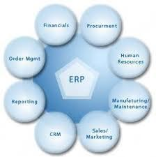

Our ERP Solutions

Our ERP solutions can be purchased by as a complete package or by module. We offer complete services from consulting, requirement analysis to development, implementation and user training for ERP systems.

Scope of ERP

Integrate Financial Information

Integrate Customer Order Information and Store Customer History

Streamline the manufacturing process

Standardizing HR Information

Store and Analyze productivity information for employees and facilities

Allow inter-departmental process monitoring and reporting

Reports with data from across the organization

Allow Marketing and Management to monitor and analyze all stages required to provide the clients with products and services

Allow users limited and monitored access to data across the organization according to needs.

ERP and E-commerce

E-Commerce has long moved from marketing trend to a proven method of increasing commerce and sales by allowing direct marketing and giving consumers the freedom of choice.

This is a twofold phenomenon which helps our clients integrate into their existing ERP system with a complete E-Commerce facility. The first channel built allows the business to communicate with the customers (B2C1) and the second channel allows suppliers and partners to communicate with the organization (B2B2). This allows clients to streamline Customer interaction while maintaining accurate records of their interaction for analyses and use in marketing strategies.

ERP: Beneficial for the Management, Marketing and Employees

ERP has many benefits for the Management and Marketing, but a properly designed and implemented system will be appreciated by Employees as well for all the benefits it offers to everyone in the organization.

The Employees are now able to store their data and productivity reports at central locations. This allows data security and allows for document sharing. This allows productivity to increase while reducing the actual work for Employees. As data access in now limited and secure, there are less chances for data theft, which removes the need for direct monitoring of employees which often makes them uncomfortable. As sub modules are developed with the help of users they are able to use systems that they are comfortable with and have received training for. This increases productivity as now the need to learn irrelevant features using third party solutions is not necessary.

The Marketing and Sales of an organization also has a lot of benefits if a robust ERP is being used. They

are able to store and analyze information pertaining to Customers‟. This could be about the status of
orders‟ or the history of each customer. By employing Data Mining and Business Intelligence Tools this
data can be used to profile customers and come up with future marketing and sales strategies that

maximize customer value.

The Management is the biggest beneficiary of a successful ERP system. They are able to monitor and get reports and all aspects of the organizations operations. This allows them to see a clearer picture of the status and direction of the organizations‟ processes.

- B2C means Business to Client

- B2B means Business to Business

Why organization buy ERP system

The main reason that drives an organization decides to impalement ERP solution is usually inefficiencies of business process. Together with delivering the obvious advantages of business process automation, enhanced operational efficiencies and easier accessibility of information, ERP system implementation surely can fix the system a company executes its day by day processes.

Organizations think about purchasing ERP system when they deal with a number of complex and interrelated business troubles. Most of them expect to get business advantages through ERP implementation, such as :

- Achieving company‟s financial goals as a result of productivity gains as well as efficiency resulting from business process automation.

- Managing and streamlining the large-scale the company‟s operational processes, that may have raised in complexity due to acquisitions in the recent past or current significant organic growth, and also acquiring multi-currency, multi-office, multi-geography support

- Replacing or upgrading the existing ERP system that is out of date or not capable of helping the company‟s day to day processes

- Obtaining the benefits of improved information management through the enhanced information accessibility, reduced data duplication and also better forecasting features.

Ten Things You Should Know about ERP System

- No exact fit: Know that no ERP package provides features that can precisely fulfill all of the company‟s business requirements. A few level of customization and configuration of the ERP package along with the business process of a company are definitely needed in the course of ERP system implementation.

- Modules vs. suite: An organization can implement only few modules as they required or the entire ERP system suite. Each one can be applied alone or perhaps in conjunction with other modules

- You have to mix and match modules: Lots of ERP system modules and functionalities are contained in different ERP packages. ERP modules are often broadly classified into 3 categories: sector-specific, cross-industry and extended ERP system modules.

- Add-on features / functionalities drive ERP: Because of the commoditization of core ERP features (for instance financial accounting), add-on features, applications of industry-specific, as well as improvements are getting to be more important and are the actual drivers of the ERP system market nowadays.

- Options to On-Premise can be found: The traditional on-premise ERP implementation has been joined by open source ERP and also on-demand / SaaS ERP as feasible ERP alternatives. Open source ERP systems have yet to really carve out a place on the market while SaaS ERP systems, particularly pertaining
to HCM and CRM, have started getting traction.

- Pricing models: The most common pricing model for ERP system is Licensed-based pricing whereas software expenses paid in advance. A variety of options available in this model consist of user-based (concurrent user and named user) pricing, package-based pricing, location-based and / or location based. One more pricing model-subscription-based pricing is typically used for on-demand ERP systems. In such model, service fees are paid on a periodic or monthly basis.

- Return On Investment (ROI) expectations: it‟s uncommon when ROI coming from ERP implementation is seen right away. In ERP case, ROI is recognized from process enhancements and not only from ERP software. Realignment of business process in any company is determined by factors, like the process complexity, number of stakeholder involved and the proposed change user acceptance, and these normally take time for being effective.

- Customization or configuration: An ERP system usually needs to be configured / set up in order to make it perform the way you would like to the extent the system allows. Additionally, the company has to modify or customize the source code or creating software to fulfill its requirements. ERP system configuration must always be pursued prior to customization. Modifications or customization must always be the last effort, since it could potentially cause the system being complex, hard to maintain, complicated to integrate with different system and also nonviable for support of ERP vendor.

- Implementation: An ERP system implementation is the most important and difficult phase in the entire process. Inadequate implementation, flawed data migration or conversion and insufficient support of post implementation can cause even feature-rich software perform poorly. On the other hand, the comprehensive implementation along with good support of post implementation obviously can make ERP software an excellent fit.

- Cost components: Along with fees for standard license and implementation services, there other small unpredicted cost components which can get out of hand as well as can take customers by surprise. These kinds of expenses comprise big unforeseen modification cost, high and recurring cost of training, data migration / conversion costs, key ERP team member‟s replacement cost and maintaining parallel systems cost.

What is ERP life cycle?

ERP lifecycle is in which highlights the different stages in implementation of An ERP.
There are different stages of the ERP implementation that are as give below:

- Pre evaluation Screening

- Evaluation Package

- Project Planning

- GAP analysis

- Reengineering

- Team training

- Testing

- Post implementation

1. Pre evaluation Screening

Once the company has decided to go for the ERP system, the search for the package must start as there are hundreds of packages it is always better to do a thorough and detailed evaluation of a small number of packages, than doing analysis of dozens of packages. This stage will be useful in eliminating those packages that are not suitable for the business process.

2. Evaluation Package

This stage is considered an important phases of the ERP implementation, as the package that one selects will decide the success or failure of the project. Implementation of an ERP involves huge investments and it is not easy to switch between different packages, so the right thing is „do it right the first time‟. Once the packages to be evaluated are identified, the company needs to develop selection criteria that permit the evaluation of all the available packages on the same scale.

3. Project Planning

This is the phase that designs the implementation process. It is in this phase that the details of how to go about the implementation are decided. Time schedules deadlines, etc for the project are arrived at. The plan is developed, roles are identified and responsibilities are assigned. It will also decide when to begin the project, how to do it and it completion. A committee by the team leaders of each implementation group usually does such a planning.

4. GAP analysis

This is considered the most crucial phase for the success of ERP implementation. This is the process through which the companies create a complete model of where they are now, and in which direction will they opt in the future. It has been estimated that even the best packages will only meet 80% of the company‟s requirements. The remaining 20% presents problematic issues for the company‟s reengineering.

5. Reengineering

It is in this phase that human factors are taken into consideration. While every implementation is going to involve a significant change in number of employees and their job responsibilities, as the process becomes more automated and efficient, it is best to treat ERP as an investment as well as cost cutting measure.

6. Team training

Training is also an important phase in the implementation, which takes place along with the process of implementation. This is the phase where the company trains its employees to implement and later, run the system. Thus, it is vital for the company to choose the right employee who has the right attitude- people who are willing to change, learn new things and are not afraid of technology and a good functional knowledge.

7. Testing

This is the phase where one tries to break the system. One has reached a point where the company is testing the real case scenarios. The system is configured and now you must come up with extreme cases like system overloads, multiple users logging on at the same time, users entering invalid data, hackers trying to access restricted areas and so on. This phase is performed to find the weak link so that it can be rectified before its implementation.

8. Post implementation

One the implementation is over, the vendor and the hired consultants will go. To reap the fruit of the implementation it is very important that the system has wide acceptance. There should be enough employees who are trained to handle problems those crops up time to time. The system must be updated with the change in technology. The post implementation will need a different set of roles and skills than those with less integrated kind of systems.

However, an organization can get the maximum value of these inputs if it successfully adopts and effectively uses the system.

Knowledge Management System

Knowledge Management System (KM System) refers to a (generally generated via or through to an IT based program/department or section) system for managing knowledge in organizations for supporting creation, capture, storage and dissemination of information. It can comprise a part (neither necessary nor sufficient) of a Knowledge Management initiative.

The idea of a KM system is to enable employees to have ready access to the organization's documented base of facts, sources of information, and solutions. For example a typical claim justifying the creation of a KM system might run something like this: an engineer could know the metallurgical composition of an alloy that reduces sound in gear systems. Sharing this information organization wide can lead to more effective engine design and it could also lead to ideas for new or improved equipment.

A KM system could be any of the following:

- Document based i.e. any technology that permits creation/management/sharing of formatted documents such as Lotus Notes, SharePoint, web, distributed databases etc.

- Ontology/Taxonomy based: these are similar to document technologies in the sense that a system of terminologies (i.e. ontology) are used to summarize the document e.g. Author, Subj, Organization etc. as in DAML & other XML based ontologies

- Based on AI technologies which use a customized representation scheme to represent the problem domain.

- Provide network maps of the organization showing the flow of communication between entities and individuals

- Increasingly social computing tools are being deployed to provide a more organic approach to creation of a KM system.

KMS systems deal with information (although Knowledge Management as a discipline may extend beyond the information centric aspect of any system) so they are a class of information system and may build on, or utilize other information sources. Distinguishing features of a KMS can include:

- Purpose: a KMS will have an explicit Knowledge Management objective of some type such as collaboration, sharing good practice or the like.

- Context: One perspective on KMS would see knowledge is information that is meaningfully organized, accumulated and embedded in a context of creation and application.

- Processes: KMS are developed to support and enhance knowledge-intensive processes, tasks or projects of e.g., creation, construction, identification, capturing, acquisition, selection, valuation, organization, linking, structuring, formalization, visualization, transfer, distribution, retention, maintenance, refinement, revision, evolution, accessing, retrieval and last but not least the application of knowledge, also called the knowledge life cycle.

- Participants: Users can play the roles of active, involved participants in knowledge networks and communities fostered by KMS, although this is not necessarily the case. KMS designs are held to reflect that knowledge is developed collectively and that the “distribution” of knowledge leads to

its continuous change, reconstruction and application in different contexts, by different participants with differing backgrounds and experiences.

- Instruments: KMS support KM instruments, e.g., the capture, creation and sharing of the modifiable aspects of experience, the creation of corporate knowledge directories, taxonomies or ontologies, expertise locators, skill management systems, collaborative filtering and handling of interests used to connect people, the creation and fostering of communities or knowledge networks.

A KMS offers integrated services to deploy KM instruments for networks of participants, i.e. active knowledge workers, in knowledge-intensive business processes along the entire knowledge life cycle. KMS can be used for a wide range of cooperative, collaborative, adhocracy and hierarchy communities, virtual organizations, societies and other virtual networks, to manage media contents; activities, interactions and work-flows purposes; projects; works, networks, departments, privileges, roles, participants and other active users in order to extract and generate new knowledge and to enhance, leverage and transfer in new outcomes of knowledge providing new services using new formats and interfaces and different communication channels.

The term KMS can be associated to Open Source Software, and Open Standards, Open Protocols and Open Knowledge licenses, initiatives and policies.
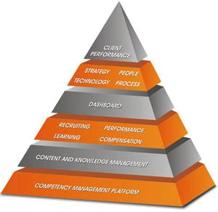

Benefits of KM Systems

Some of the advantages claimed for KM systems are:

- Sharing of valuable organizational information throughout organizational hierarchy.

- Can avoid re-inventing the wheel, reducing redundant work.
- May reduce training time for new employees
- Retention of Intellectual Property after the employee leaves if such knowledge can be codified.

How can info Router help you with Knowledge Management

- Promotes sharing and collaboration of corporate knowledge and intellectual assets.

- Easy access to fresh and timely content

- Notification mechanism that alerts knowledge workers to new and edited documents

- Robust tools to search and retrieve existing information and knowledge so that this information can be reused and not regenerated.

- Classification and Categorization of information for easy access and retrieval.

- Meta Data Definitions so that documents and information can be accessed quickly based on consistent corporate criteria.

- Templates to create information so that all information reflects the familiar corporate standards.

- Knowledge Management Portals to distribute timely content

- An effective Notification system that creates an informed community of users.

- An environment that supports and allows a community of users to contribute information and knowledge.

Knowledge and the Firm:

An Overview and basic concepts the question of defining knowledge has occupied the minds of philosophers since the classical Greek era and has led to many epistemological debates. It is unnecessary for the purposes of this paper to engage in a debate to probe, question, or reframe the term knowledge, or discover the .universal truth, From the perspective of ancient or modern philosophy. This is because such an understanding of knowledge was neither a determinant factor in building the knowledge-based theory of the firm nor in triggering researcher and practitioner interest in managing organizational knowledge. It is, however, useful to consider the manifold views of knowledge as discussed in the information technology (IT), strategic management, and organizational theory literature. This will enable us to uncover some assumptions about knowledge that underlie organizational knowledge management processes and KMS. We will begin by considering definitions of knowledge.

Knowledge Management in Organizations

The recent interest in organizational knowledge has prompted the issue of managing the knowledge to the organization‟s benefit. Knowledge management refers to identifying and leveraging the collective knowledge in an organization to help the organization compete. Knowledge management is purported to increase innovativeness and responsiveness (Hackbarth 1998). A recent survey of European firms by KPMG Peat Marwick (1998b) found that almost half of the companies reported having suffered a significant setback from losing key staff with 43% experiencing impaired client or supplier relations and 13% facing a loss of income because of the departure of a single employee. In another survey, the majority of organizations believed that much of the knowledge they needed existed inside the organization, but that identifying that it existed, finding it, and leveraging it remained problematic (Cranfield University 1998). Such problems maintaining, locating, and applying knowledge have led to systematic attempts to manage knowledge.

According to Davenport and Prusak (1998), most knowledge management projects have one of three aims:

- to make knowledge visible and show the role of knowledge in an organization, mainly through maps, yellow pages, and hypertext tools;

- to develop a knowledge-intensive culture by encouraging and aggregating behaviors such
as knowledge sharing (as opposed to hoarding) and proactively seeking and offering knowledge;

- To build a knowledge infrastructure. Not only a technical system, but a web of connections among people given space, time, tools, and encouragement to interact and collaborate.

Knowledge management is largely regarded as a process involving various activities. Slight discrepancies in the delineation of the processes appear in the literature, namely in terms of the number and labeling of processes rather than the underlying concepts. At a minimum, one considers the four basic processes of creating, storing/retrieving, transferring, and applying knowledge. These major processes can be subdivided, for example, into creating internal knowledge, acquiring external knowledge, storing knowledge in documents versus storing in routines (Teece 1998) as well as updating the knowledge and sharing knowledge internally and externally. We will return to the knowledge management processes in the framework section and consider the role of IT within each process.
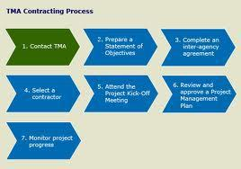

Role of Knowledge Management Systems




knowledge

BIBLIOGRAPHY

http://www.blurtit.com/q6105662.html
http://e-learning.mfu.ac.th/mflu/1203371/Chapter1_3.htm
http://whatiserp.net/erp-basic-knowledge/erp-system/

http://www.businessballs.com/crmcustomerrelationshipmanagement.htm

http://www.tlainc.com/articl83.htm
http://en.wikipedia.org/wiki/Knowledge_management
http://www.inforouter.com/knowledge_management.asp

